RAJALAKSHMI ENGINEERING COLLEGE
An Autonomous Institution, Affiliated to Anna University
Rajalakshmi Nagar, Thandalam – 602 105

R-2023
VII SEMESTER
B.Tech. – Artificial Intelligence & Data Science
CS23633 – CLOUD COMPUTING
LABORATORY MANUAL

NAME : MOGHANAPRIYA R
REGISTER NO : 2116231801102
ACADEMIC YEAR : 2026-2027


BONAFIDE CERTIFICATE
NAME : MOGHANAPRIYA R ACADEMIC YEAR ... 2026-2027 .......
SEMESTER ..... VII ..... BRANCH: ........ Artificial Intelligence and Data Science
2116231801102
UNIVERSITY REGISTER No.
Certified that this is the bonafide record of work done by the above student in the Cloud Computing Laboratory during the year 2026 - 2027.
Signature of Faculty - in – Charge

Submitted for the Practical Examination held
on ..................................

Internal Examiner | External Examiner

INDEX
S.No | Name of the Experiment | Date | Github QR | Faculty Sign
1 | Private Cloud Using Openstack | 24.06.2026 | 
2 | PaaS in Public Cloud Using Render | 08.07.2026 | 
3 | Setting Up Hybrid Cloud Connectivity Using Cisco Packet Tracer | 22.07.2026 | 
4 | Virtual Private Server (VPS) Provisioning and Configuration | 05.08.2026 | 
5 | Cloud Backup and Migration using Google Drive | 14.08.2026 | 
6 | CDN Service Selection and Configuration | 21.08.2026 | 

EXP NO 1 | PRIVATE CLOUD USING OPENSTACK
Date: 24.06.2026 | PRIVATE CLOUD USING OPENSTACK
Aim
To deploy and configure a single-node private cloud environment using OpenStack MicroStack and to study its major cloud services such as computing, networking, identity management, and storage. The experiment also involves creating and accessing virtual machine resources through the OpenStack web dashboard.
Introduction to OpenStack
OpenStack is an open-source cloud computing platform used to build, deploy, and manage cloud infrastructure. It mainly provides Infrastructure as a Service (IaaS).
OpenStack allows cloud administrators to manage various physical and virtual resources such as:
- Compute resources
- Storage resources
- Network resources
These resources can be allocated to users based on their requirements. Users can create and manage virtual machines and other cloud resources using the OpenStack platform.
OpenStack is commonly used for building private and hybrid cloud environments. In contrast, platforms such as AWS and Microsoft Azure mainly provide public cloud services.
What is MicroStack?
MicroStack is a lightweight and simplified distribution of OpenStack that allows OpenStack to be installed and configured with minimal effort.
MicroStack is mainly useful for:
- Learning OpenStack concepts
- Testing cloud infrastructure
- Development and experimentation
- Running OpenStack on a single computer or virtual machine
In this experiment, MicroStack is deployed on Ubuntu 22.04 LTS running inside VMware. Since this is a single-node deployment, the required OpenStack services operate on the same system.
Major OpenStack Services
OpenStack Service | Main Purpose
Nova | Creates, runs, and manages virtual machines
Neutron | Provides networking services such as virtual networks, IP addresses, and connectivity
Keystone | Provides authentication, authorization, and identity management
Glance | Stores and manages virtual machine images used for creating instances
Horizon | Provides a web-based graphical dashboard for managing OpenStack resources
Cinder | Provides persistent block storage that can be attached to virtual machines
Swift | Provides object-based storage for storing and managing data
Software / Environment Used
- Operating System: Ubuntu 22.04 LTS (Jammy)
- Cloud Platform: OpenStack MicroStack
- Virtualization Platform: VMware
- Deployment Type: Single-node OpenStack
- Interface: Horizon Web Dashboard
Procedure
Step 1: Install MicroStack
Open the Ubuntu terminal and execute the following command:
sudo snap install microstack --beta
This command downloads and installs the MicroStack package along with the required OpenStack components.
Step 2: Verify the Installation
After installing MicroStack, verify the installation using the following command:
snap list microstack
The command displays information about the installed MicroStack package and its version.
Step 3: Install Python Compatibility Package
Install the required Python compatibility package using:
sudo apt install python-is-python3
This ensures that the python command refers to the installed Python 3 interpreter.
Step 4: Initialize MicroStack
Initialize the MicroStack environment using the following command:
sudo microstack init --auto --control
This command automatically configures the required OpenStack services and prepares the system for use as a single-node private cloud.
Step 5: Access the OpenStack Dashboard
After the initialization process is completed, open a web browser inside the Ubuntu environment and enter the following address:
10.20.20.1
The OpenStack Horizon dashboard will then be displayed.
Step 6: Login to Horizon
Use the following username to access the Horizon dashboard:
Username: admin
To obtain the automatically generated Keystone administrator password, execute the following command in the Ubuntu terminal:
sudo snap get microstack config.credentials.keystone-password
The command displays the administrator password. Copy the displayed password and enter it along with the username admin on the Horizon login page.
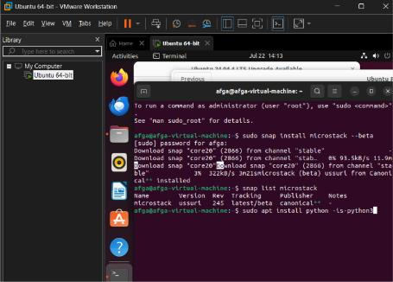
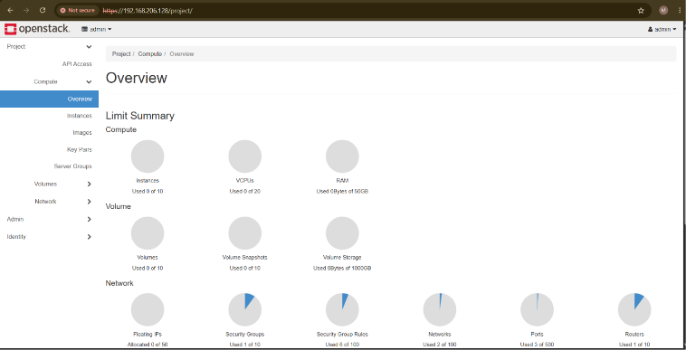
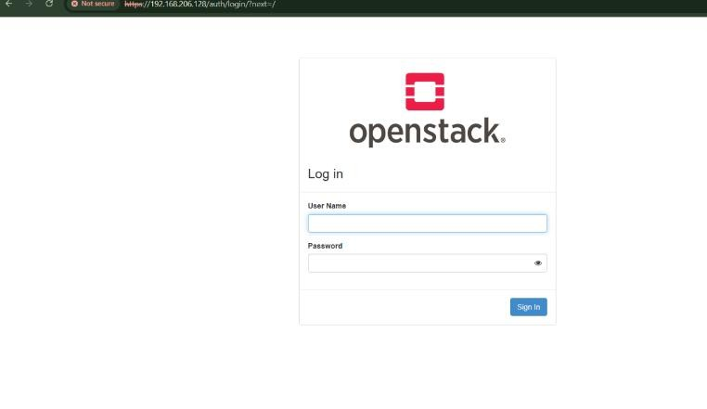
Conclusion
A single-node Private Cloud environment was successfully set up using OpenStack (MicroStack). The OpenStack services were properly installed and configured, and the private cloud was able to launch, manage, and access virtual machine instances with functional compute, networking, and storage services, thereby meeting the objectives of the experiment.

EXP NO 2 | PaaS IN PUBLIC CLOUD USING RENDER
Date: 08.07.2026 | PaaS IN PUBLIC CLOUD USING RENDER
Aim
To deploy a web application on a Platform-as-a-Service (PaaS) cloud environment using Render, and to understand how PaaS enables application deployment and scaling without the need to manage the underlying servers or infrastructure.
Introduction to PaaS and Render
Platform as a Service (PaaS) is a cloud computing model that provides a ready-to-use platform for developing, deploying, and managing applications, without requiring the user to manage the underlying operating system, servers, or networking infrastructure. The cloud provider handles provisioning, scaling, patching, and runtime management, allowing developers to focus purely on application code.
Render is a modern PaaS platform that allows developers to build, deploy, and host web applications, APIs, static sites, and background services directly from a GitHub or GitLab repository. Render automatically builds the application, provisions the required infrastructure, and exposes the deployed application through a public URL.
Key benefits of using a PaaS platform such as Render include:
- No manual server setup, patching, or operating-system management
- Automatic builds and deployments triggered from source-code repository changes
- Built-in HTTPS, load balancing, and auto-scaling
- Faster development-to-deployment cycle compared to IaaS
Software / Environment Used
- Cloud Platform: Render (PaaS)
- Source Control: GitHub repository
- Application: Sample Node.js / static web application
- Interface: Render Web Dashboard
Procedure
Step 1: Create a Render Account
A Render account was created at render.com using a valid email address, and the account was verified and signed in to the Render dashboard.
Step 2: Prepare the Application Repository
A sample web application was created and pushed to a new GitHub repository. The repository included the application source code along with the required start and build configuration (such as package.json for a Node.js application).
Step 3: Create a New Web Service on Render
From the Render dashboard, New → Web Service was selected, and the application's GitHub repository was connected and authorized for access.
Step 4: Configure the Build and Start Settings
The build command and start command for the application were specified, the runtime environment was selected, and the free instance type was chosen for deployment.
Build Command: npm install
Start Command: npm start
Step 5: Deploy the Web Service
The Create Web Service option was selected. Render automatically pulled the source code, installed the dependencies, built the application, and deployed it to its managed infrastructure.
Step 6: Access and Verify the Deployed Application
Once the deployment completed successfully, Render generated a public URL ending with onrender.com. The application was accessed through this URL in a web browser, and the deployment logs and service status were verified from the Render dashboard.
Screenshots – Render Deployment
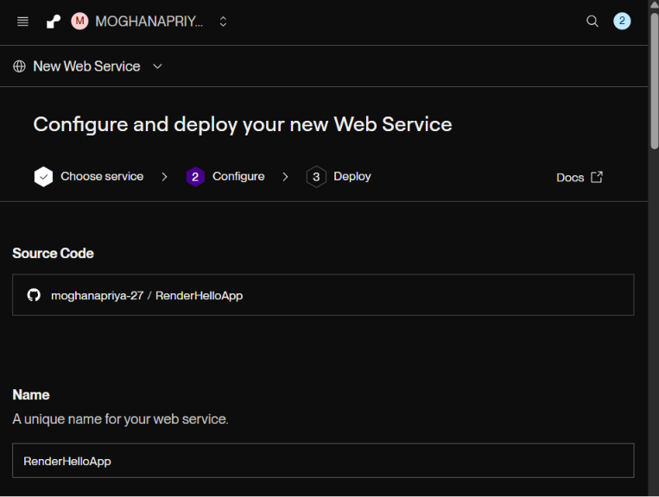
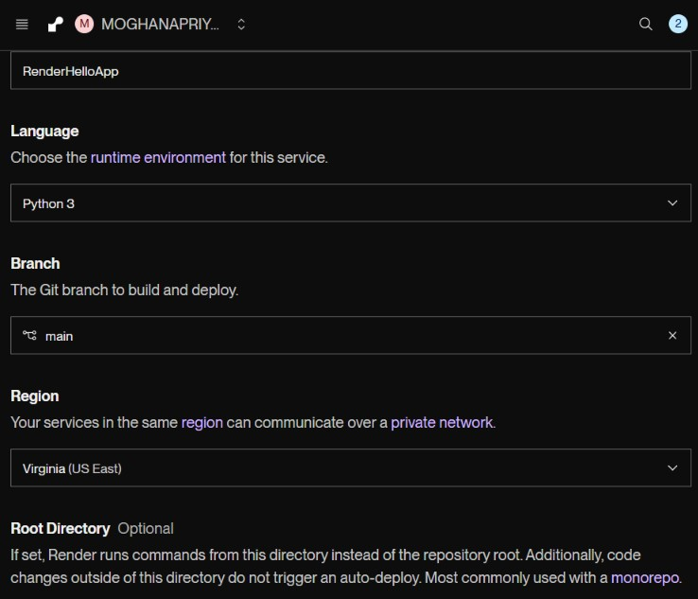
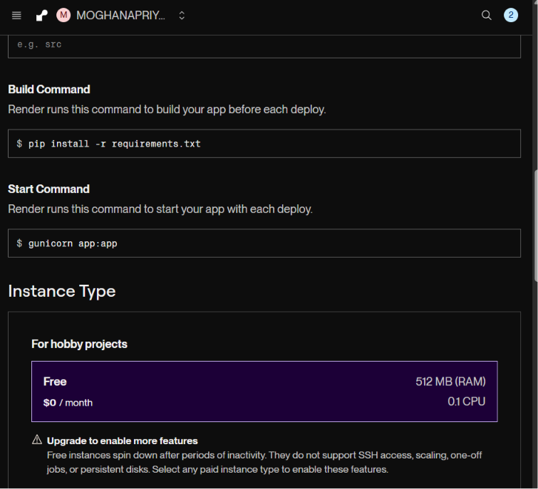
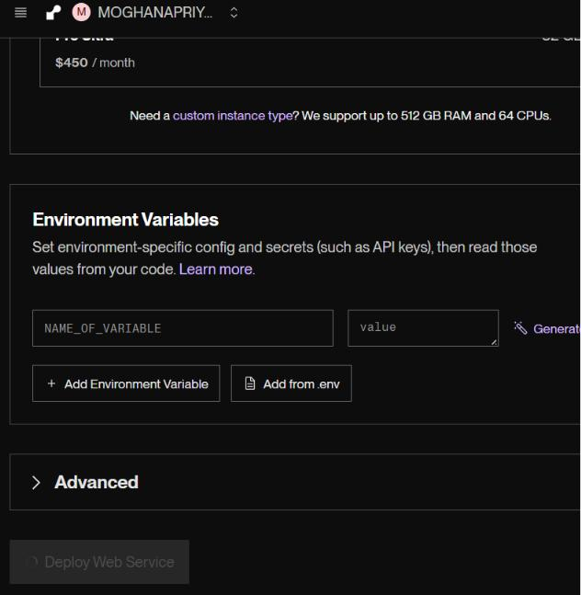
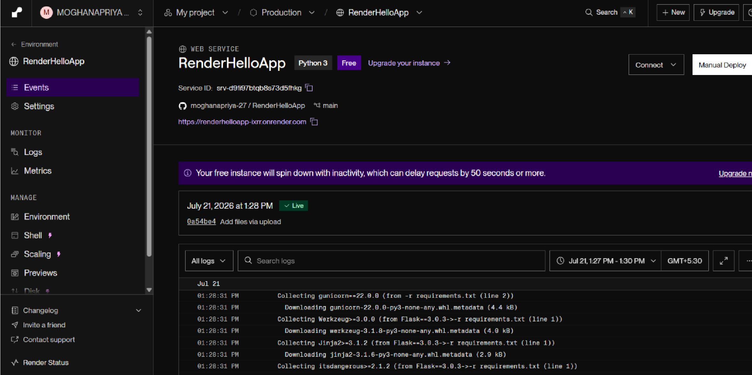
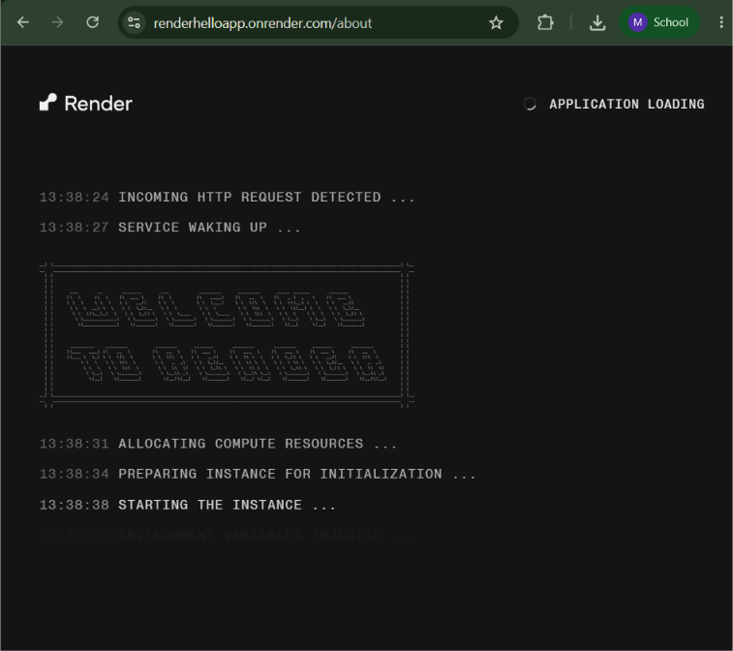
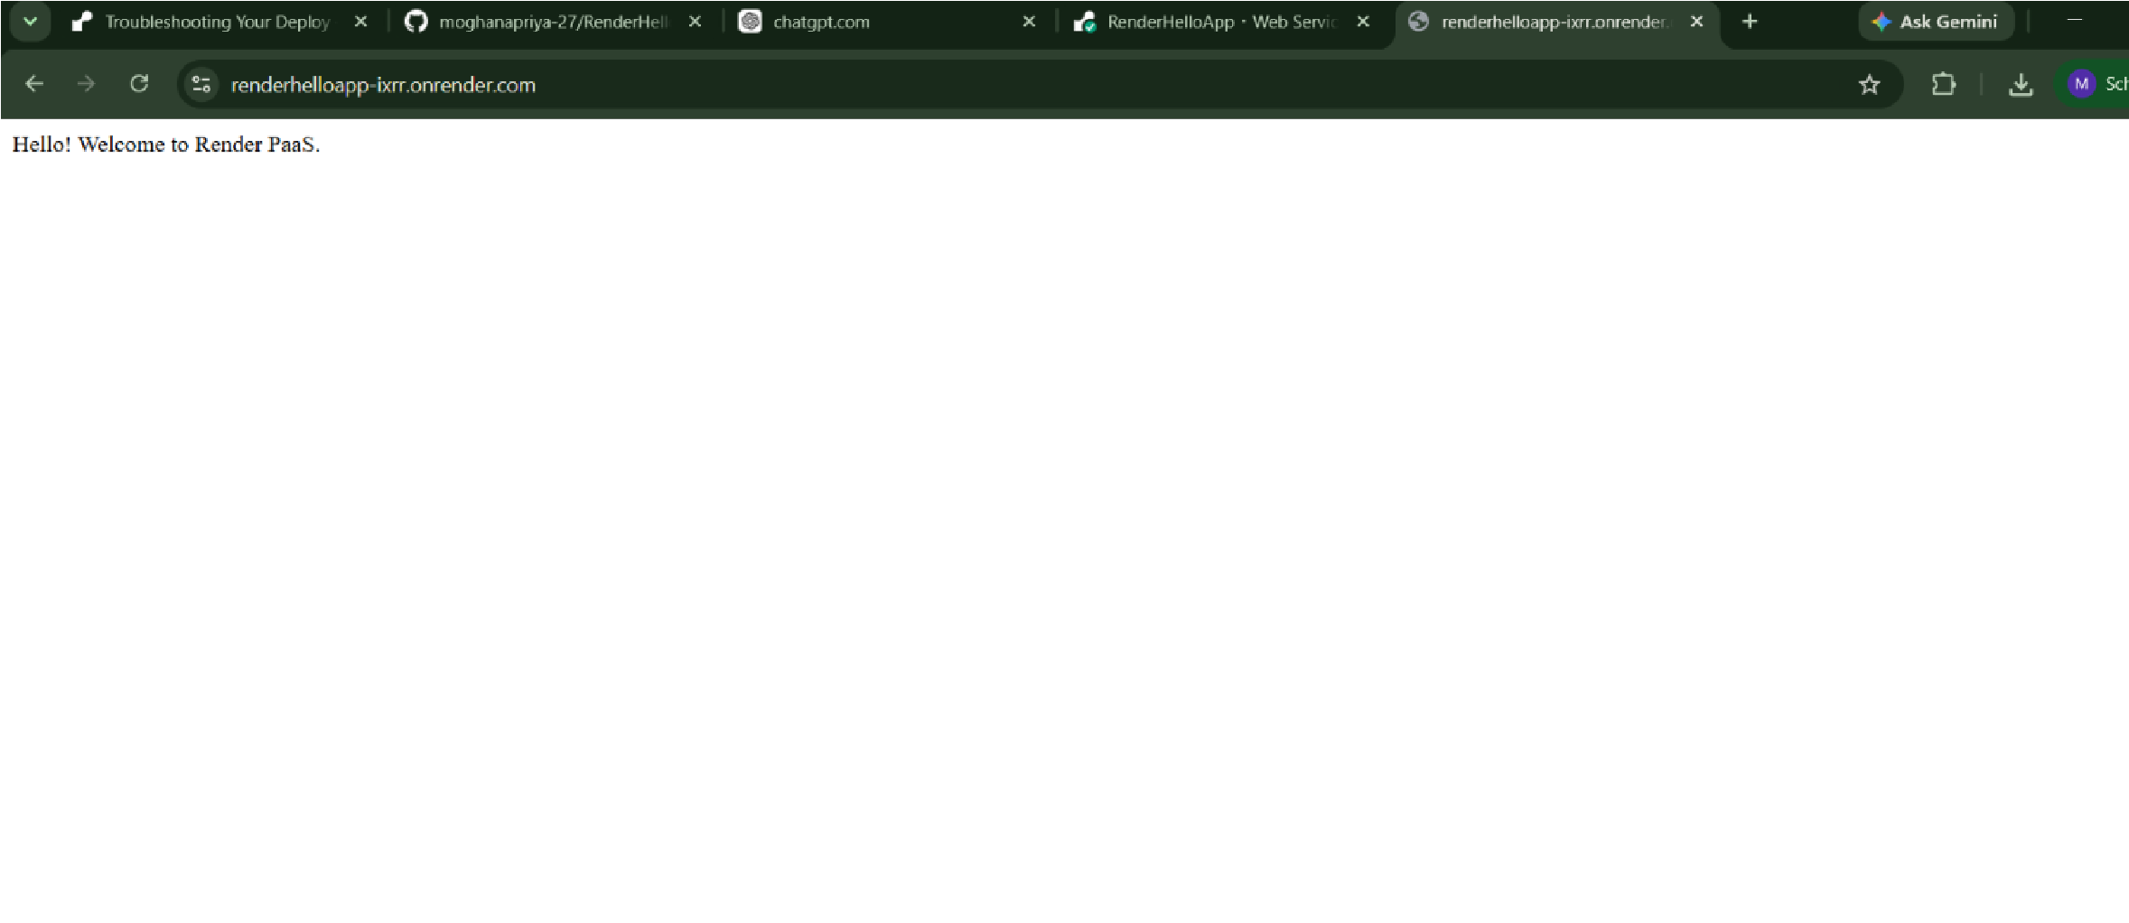
Conclusion
A web application was successfully deployed on the Render PaaS platform. The experiment demonstrated how a Platform-as-a-Service model automates build, deployment, and hosting directly from a source-code repository, without requiring manual server or infrastructure management, thereby meeting the objectives of the experiment.

EXP NO 3 | SETTING UP HYBRID CLOUD CONNECTIVITY USING CISCO PACKET TRACER
Date: 22.07.2026
Aim
To design and simulate a hybrid cloud network topology connecting a private on-premises network with a public cloud environment using Cisco Packet Tracer, and to verify connectivity between the private network and the simulated cloud.
Introduction to Hybrid Cloud
Hybrid Cloud is a cloud computing model that combines a private, on-premises infrastructure with a public cloud, allowing data and applications to be shared between them. It gives organizations the flexibility to keep sensitive workloads on the private network while using the public cloud for scalability, backup, or additional compute resources.
Cisco Packet Tracer is a network simulation tool that allows students and administrators to design, configure, and test network topologies, including routers, switches, end devices, and a built-in Cloud component that can be used to represent connectivity to an external / public cloud network.
A hybrid cloud connectivity setup typically involves:
- A private network segment (LAN) with end devices, a switch, and a router
- A router configured with Network Address Translation (NAT) or a routed WAN link
- A Cloud component representing the public cloud network
- Routing / NAT configuration to allow communication between the two networks
Software / Environment Used
- Simulation Tool: Cisco Packet Tracer
- Devices: Router, Switch, PCs, Cloud component
- Protocols: IP Addressing, Static Routing, NAT
Procedure
Step 1: Launch Cisco Packet Tracer and Create a New Project
Cisco Packet Tracer was launched and a new blank workspace was created for designing the hybrid cloud topology.
Step 2: Build the Private (On-Premises) Network
A router and a switch were placed on the workspace, and two or more PCs were connected to the switch to represent the private LAN. All devices were connected using the appropriate copper straight-through and crossover cables.
Step 3: Add the Cloud Component
A Cloud component was added from the WAN Emulation category to represent the public cloud network, and it was connected to the WAN-facing interface of the router using a serial or Ethernet link, as supported by Packet Tracer.
Step 4: Configure IP Addressing on the Private Network
Static IP addresses were assigned to the PCs and to the LAN interface of the router. The default gateway on each PC was set to the router's LAN interface address.
PC IP: 192.168.1.10 /24 Gateway: 192.168.1.1
Router LAN Interface: 192.168.1.1 /24
Step 5: Configure the WAN Link to the Cloud
The router's WAN-facing interface connected to the Cloud component was configured with a public-style IP address, and the interface was enabled using the no shutdown command.
Router(config)# interface <wan-interface>
Router(config-if)# ip address <public-ip> <subnet-mask>
Router(config-if)# no shutdown
Step 6: Configure Routing / NAT
A static default route (or NAT overload configuration) was added on the router so that traffic from the private LAN could reach the cloud-side network through the WAN interface.
Router(config)# ip route 0.0.0.0 0.0.0.0 <wan-interface>
Step 7: Verify Hybrid Cloud Connectivity
Connectivity between a private-network PC and the cloud-side endpoint was verified using the ping command from the PC command prompt. A successful reply confirmed that the private on-premises network was able to communicate with the simulated public cloud.
C:\> ping <cloud-endpoint-ip>
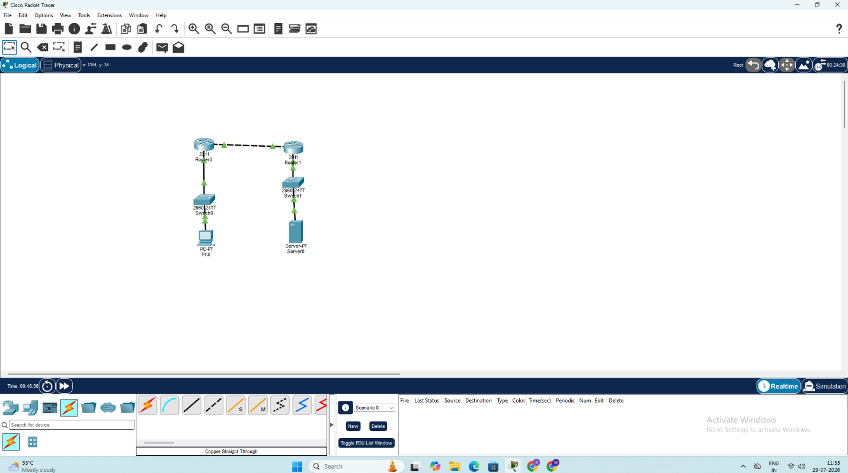

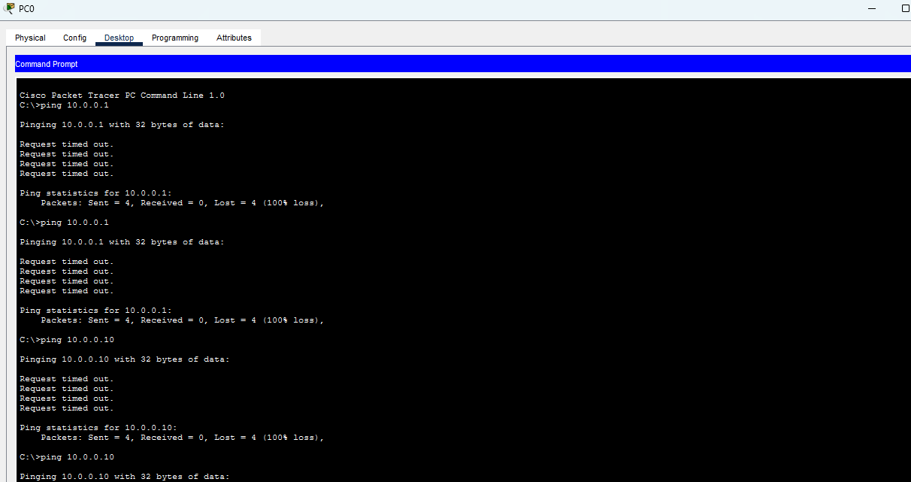

Conclusion
A hybrid cloud network topology connecting a private on-premises network with a simulated public cloud was successfully designed and configured using Cisco Packet Tracer. IP addressing, routing, and connectivity between the private network and the cloud component were verified, thereby meeting the objectives of the experiment.

EXP NO 4 | VIRTUAL PRIVATE SERVER (VPS) PROVISIONING AND CONFIGURATION
Date: 05.08.2026 | VIRTUAL PRIVATE SERVER (VPS) PROVISIONING AND CONFIGURATION
Aim
To set up a Virtual Private Server (VPS) environment using VirtualBox, install the Ubuntu Server operating system, configure network settings such as IP address, subnet mask, gateway, and DNS, and enable secure remote access using SSH.
What is a VPS?
A Virtual Private Server (VPS) is a virtual server created using virtualization technology. It operates as an independent server with its own operating system, storage, memory, and network configuration, even though the physical resources of the host system may be shared with other virtual machines. Virtualization allows physical computing resources to be utilized efficiently and is an important technology used in cloud computing environments.
Network Configuration Parameters
Parameter | Description
IP Address | A unique numerical identifier assigned to a device on a network. It helps identify the device and enables communication with other systems.
Subnet Mask | Used to determine the network and host portions of an IP address. It helps identify which devices belong to the same network.
Gateway | Acts as a communication point between the local network and external networks, allowing devices to send and receive data outside their local network.
DNS | Converts human-readable domain names into their corresponding IP addresses, helping computers locate websites and other network services.
SSH | A secure communication protocol used to remotely access and manage Linux-based systems through a command-line interface.
Procedure
Step 1: Check Internet Connectivity
The Ubuntu terminal was opened and the internet connection was verified by executing the following command:
ping google.com
Step 2: Check Network Routing
The current network routing information of the Ubuntu system was displayed using:
ip route
Step 3: Verify DNS Configuration
The DNS configuration was checked by executing:
cat /etc/resolv.conf
Step 4: Update Package Repository
The Ubuntu package repository information was updated using:
sudo apt update
Step 5: Install OpenSSH Server
The OpenSSH Server package was installed to enable secure remote connections:
sudo apt install openssh-server -y
Step 6: Enable SSH Service
The SSH service was enabled so that it starts automatically whenever the system boots:
sudo systemctl enable ssh
Step 7: Start SSH Service
The SSH service was started using the following command:
sudo systemctl start ssh
Step 8: Check SSH Service Status
Whether the SSH service was running correctly was verified by executing:
sudo systemctl status ssh
The service displayed the status as “active (running)”, confirming it was functioning correctly.
Step 9: Find the IP Address
The IP address assigned to the Ubuntu system was obtained using:
hostname -I
Step 10: Establish SSH Connection
A secure remote connection to the Ubuntu system was established using:
ssh <username>@<IP_address>
Here, <username> was replaced with the Ubuntu username and <IP_address> with the IP address obtained in the previous step.
Step 11: Verify SSH Login
The SSH connection was confirmed to have been successfully established by checking the Ubuntu welcome / login message displayed in the terminal.
Screenshots – VPS Terminal Session
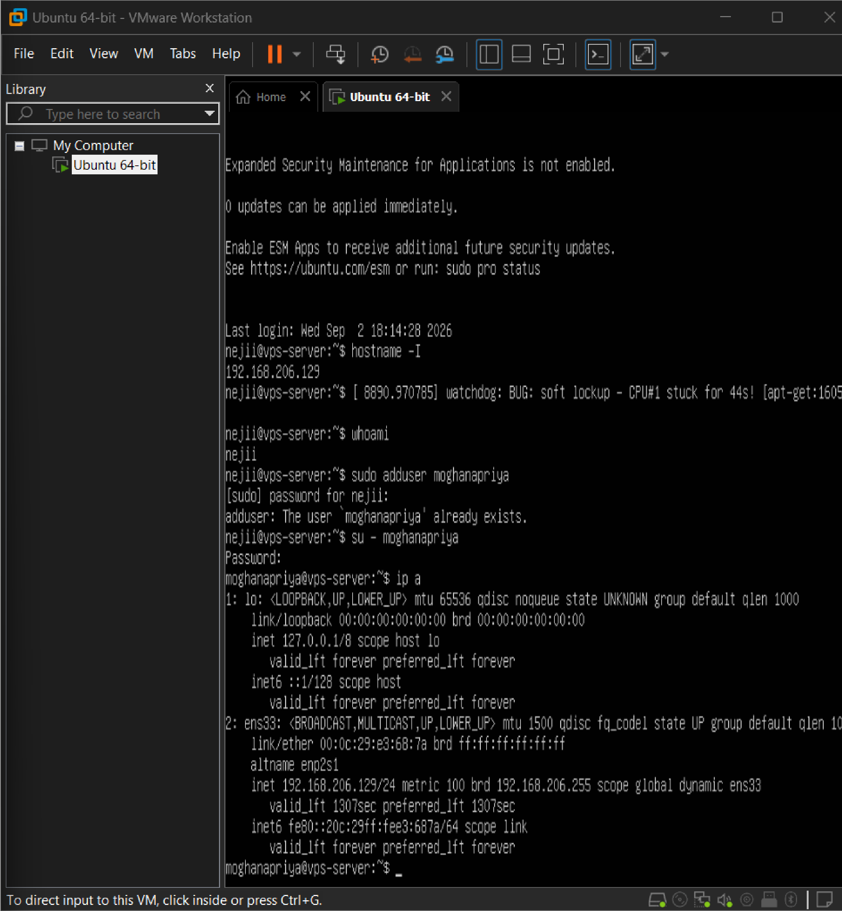
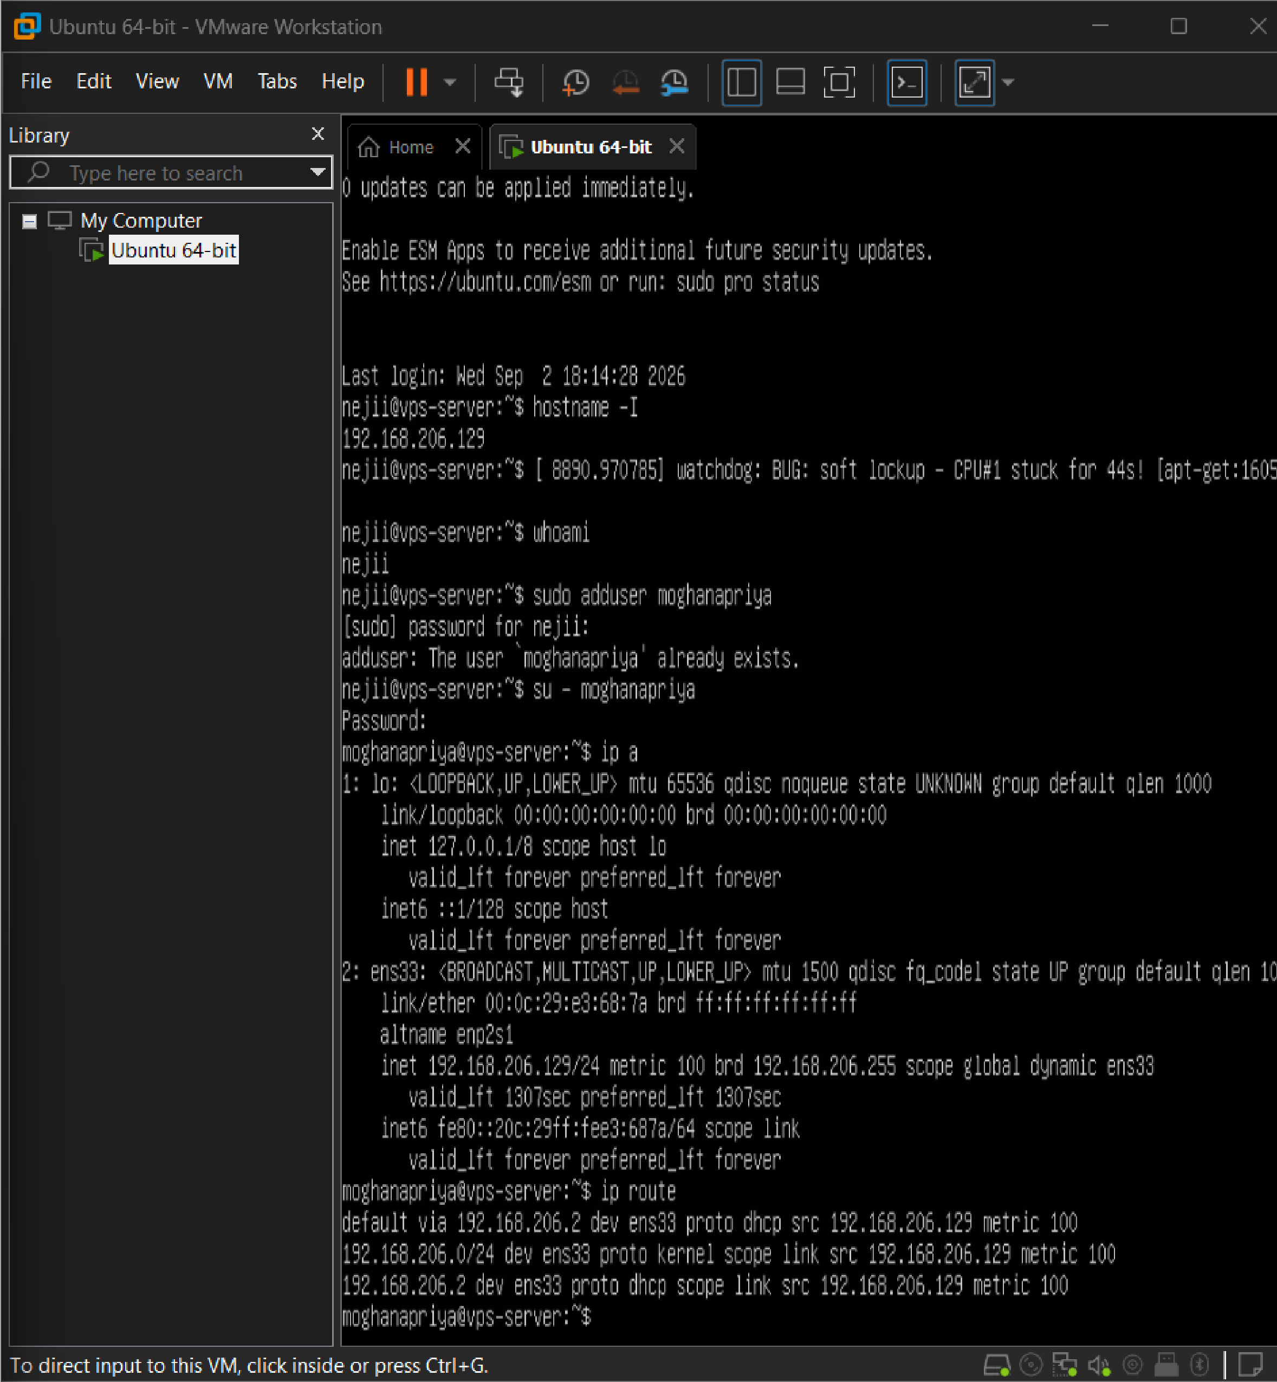
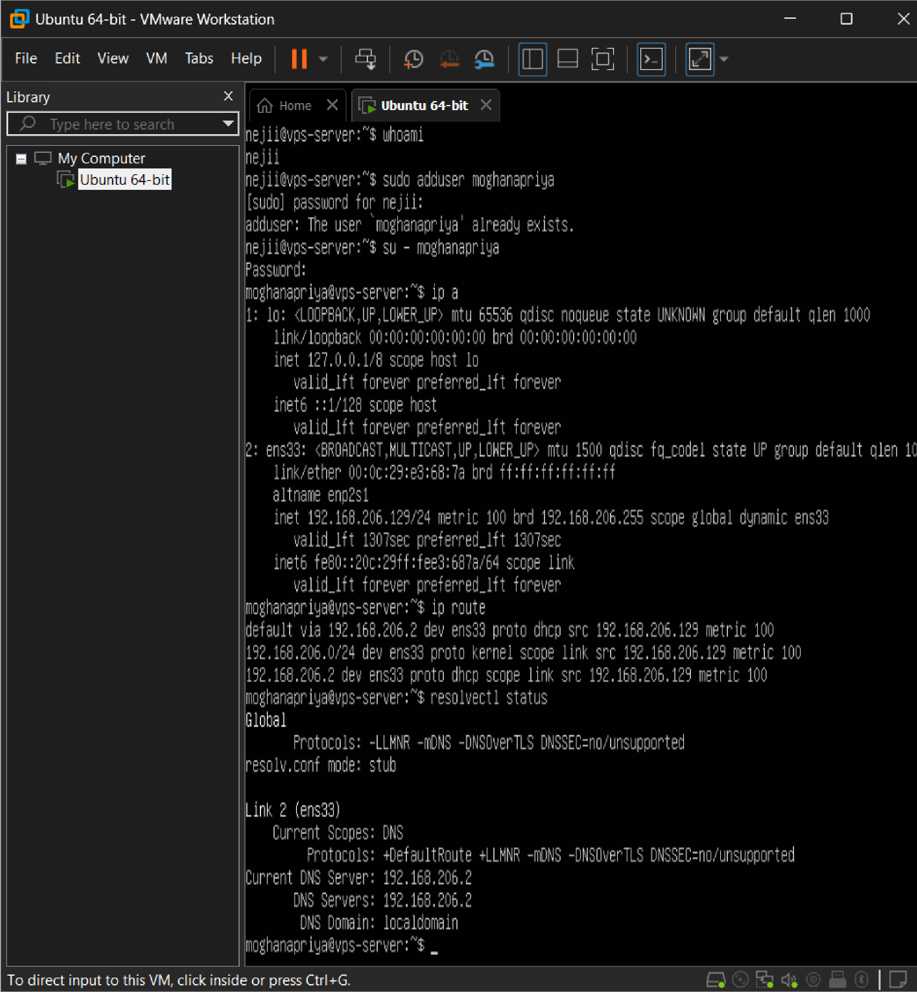
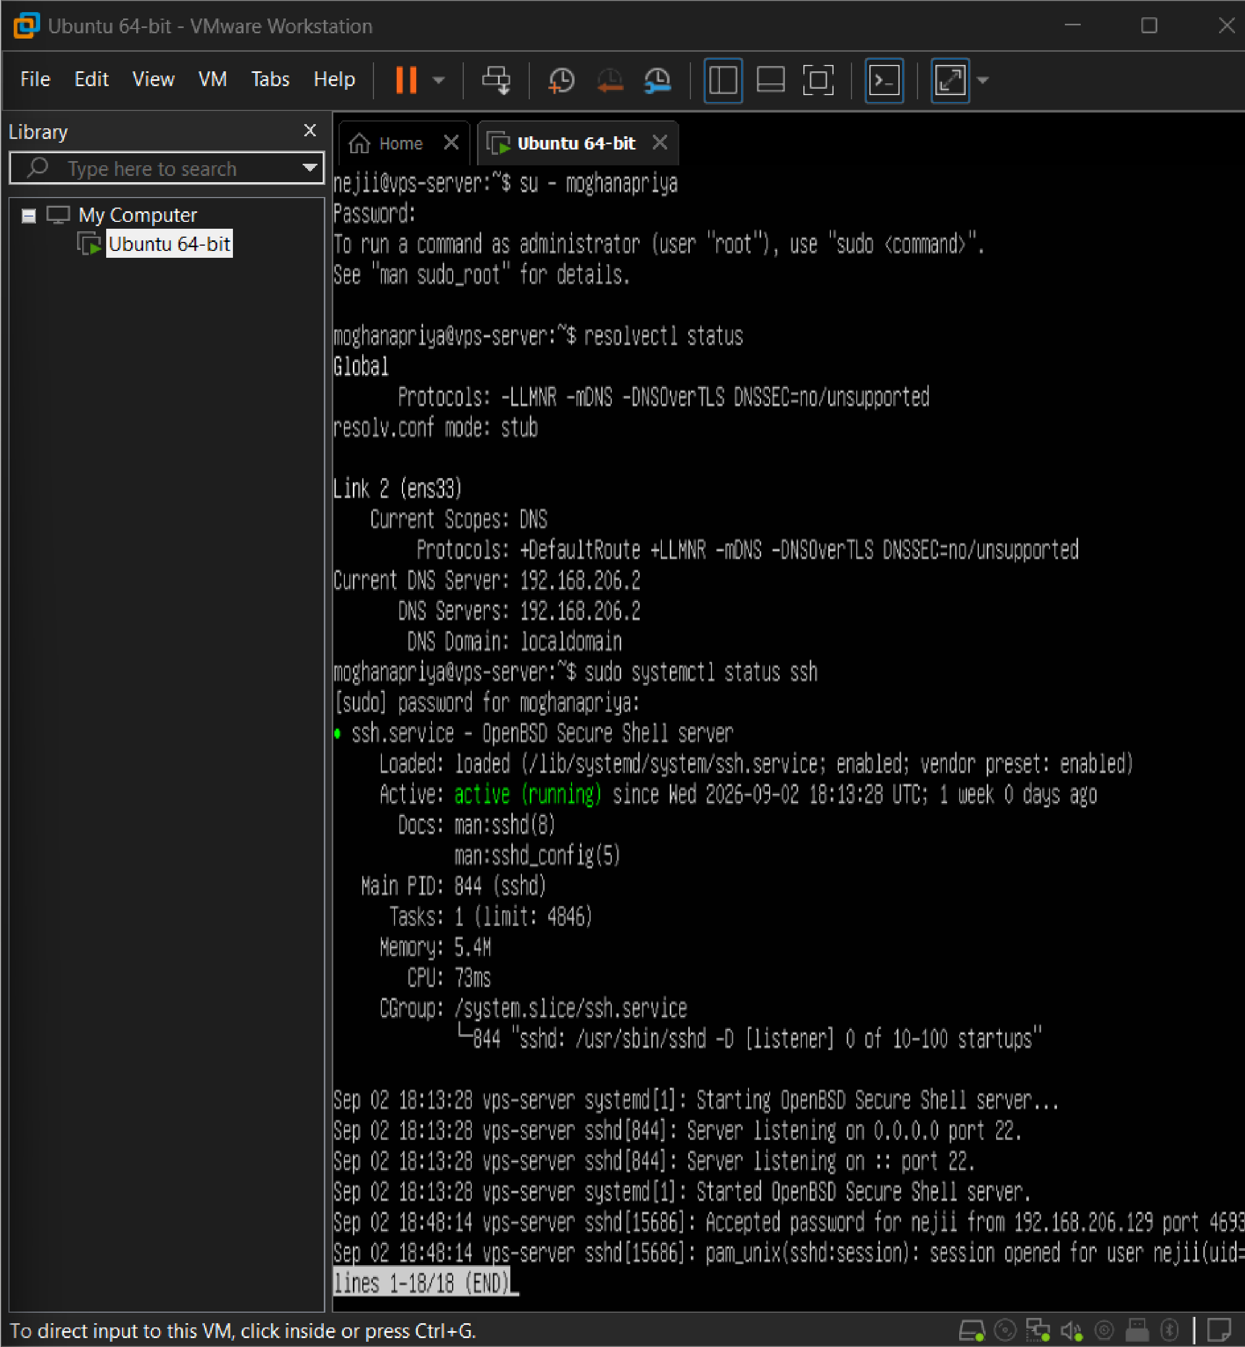
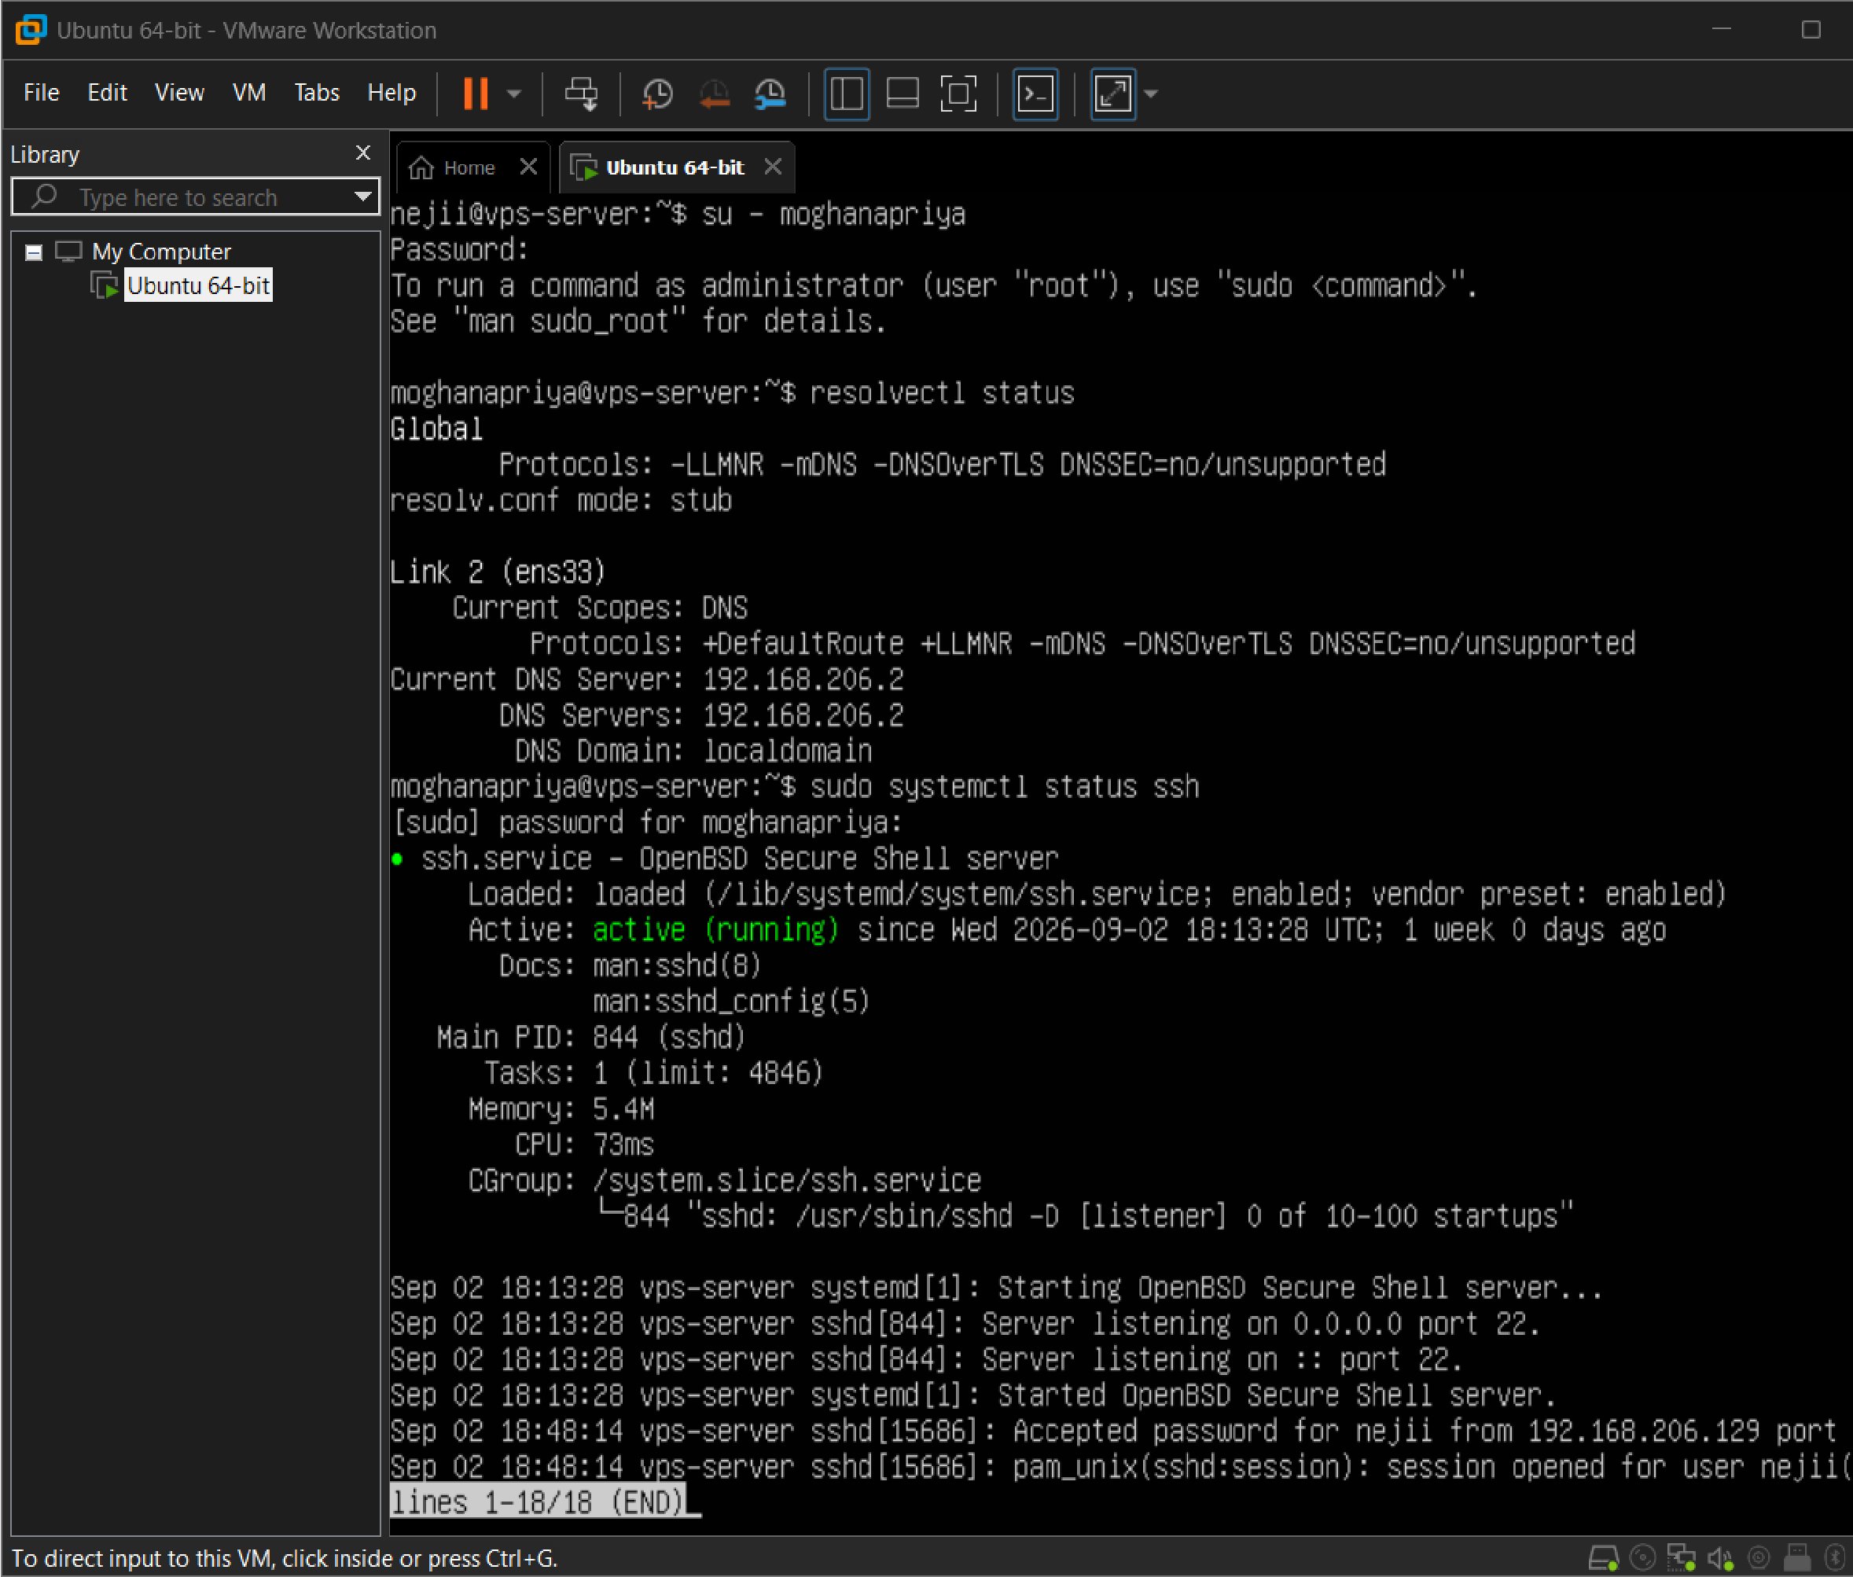

Conclusion
A Virtual Private Server environment was successfully set up using VirtualBox and Ubuntu Server. The required network parameters were configured, the OpenSSH server was installed and enabled, and secure remote access to the VPS was established and verified using SSH, thereby meeting the objectives of the experiment.

EXP NO 5 | CLOUD BACKUP AND MIGRATION USING GOOGLE DRIVE
Date: 14.08.2026 | CLOUD BACKUP AND MIGRATION USING GOOGLE DRIVE
Aim
To create a cloud backup system by storing important files in Google Drive, enabling automatic synchronization, and verifying successful backup completion.
Requirements
- Windows 10/11
- Google Account
- Internet Connection
- Google Drive for Desktop
Procedure
Part A – Create Sample Data
Step 1: Create a Folder
A folder named OfficeData was created on the Desktop.
Step 2: Create Text Files
Three text files were created inside the OfficeData folder, and sample data was entered into each:
- Student.txt – Name : Student, Department : AI & DS
- Attendance.txt – Attendance : 95%
- Marks.txt – Cloud Computing : 98
The resulting folder structure was:
OfficeData
├── Student.txt
├── Attendance.txt
└── Marks.txt
Part B – Create Cloud Storage
Step 3: Open Google Drive
Google Drive was opened in a web browser using a Google account.
Step 4: Create CloudBackup Folder
A new folder named CloudBackup was created in Google Drive.
Part C – Upload Files to the Cloud
Step 5: Upload Sample Files
The three files — Student.txt, Attendance.txt, and Marks.txt — were selected from the local OfficeData folder and uploaded to the CloudBackup folder in Google Drive. This demonstrated the migration of local data to cloud storage.
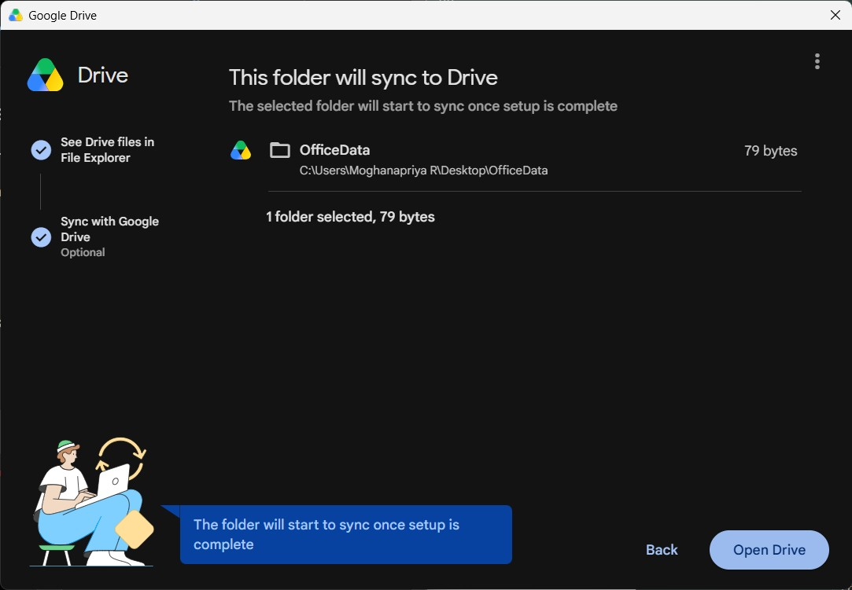
Part D – Install and Configure Google Drive for Desktop
Step 6: Configure Google Drive Synchronization
Google Drive for Desktop was opened and configured using the same Google account. The local OfficeData folder was selected for synchronization with Google Drive. After configuration, the Google Drive application successfully uploaded Student.txt, Marks.txt, and Attendance.txt, and the synchronization status displayed “Up to date.”
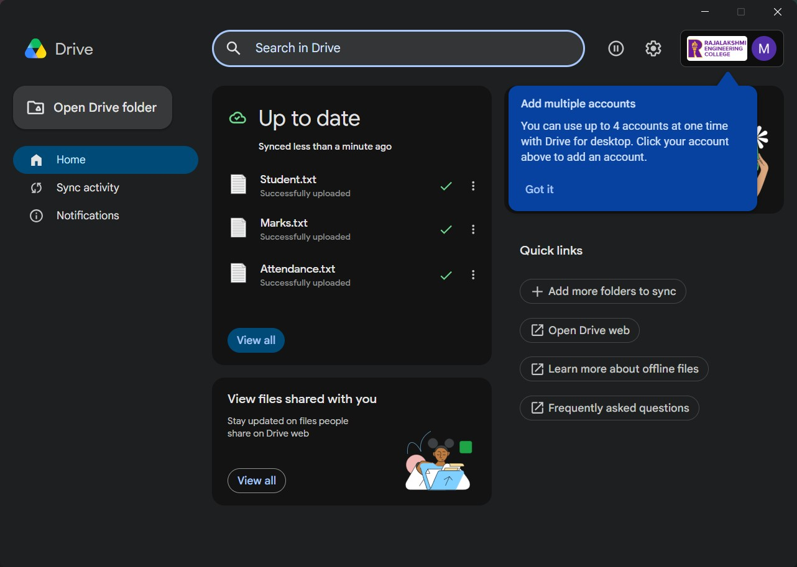
Part E – Verify Cloud Backup
The synchronization status was checked in Google Drive for Desktop. All three files showed successful upload status, and the overall Google Drive status displayed “Up to date,” confirming that the local OfficeData files were successfully backed up to Google Drive.
Experiment Flow
Local Computer → OfficeData Folder → Student.txt + Attendance.txt + Marks.txt → Google Drive → Cloud Storage → Automatic Synchronization → Up to date → Cloud Backup Completed
Conclusion
The cloud migration and backup setup experiment was successfully completed using Google Drive. Important local files were migrated to cloud storage, automatic synchronization was configured, and all files were successfully uploaded. The synchronization status displayed “Up to date,” confirming the successful completion of the cloud backup process.

EXP NO 6 | CDN SERVICE SELECTION AND CONFIGURATION USING CLOUDFLARE
Date: 21.08.2026 | CDN SERVICE SELECTION AND CONFIGURATION USING CLOUDFLARE
Aim
To select a Content Delivery Network (CDN) provider, deploy a simple web application using Cloudflare Workers, access the application through Cloudflare's edge network, and verify the HTTP response and Cloudflare-specific headers using browser Developer Tools.
Requirements
- Windows 10/11
- Google Chrome or any modern web browser
- Cloudflare Account
- Internet Connection
- Chrome Developer Tools
Procedure
Part A – Select the CDN Provider
Step 1: Select a CDN Provider
A Content Delivery Network provider was selected for implementing the experiment. The available CDN providers considered included Cloudflare, Amazon CloudFront, and Akamai. Cloudflare was selected because it provides CDN, security, DNS, and edge computing services, and allows simple deployment of applications using Cloudflare Workers.
Part B – Create and Deploy a Cloudflare Worker
Step 2: Access Cloudflare
The Cloudflare dashboard was accessed through a web browser by logging in with a valid Cloudflare account.
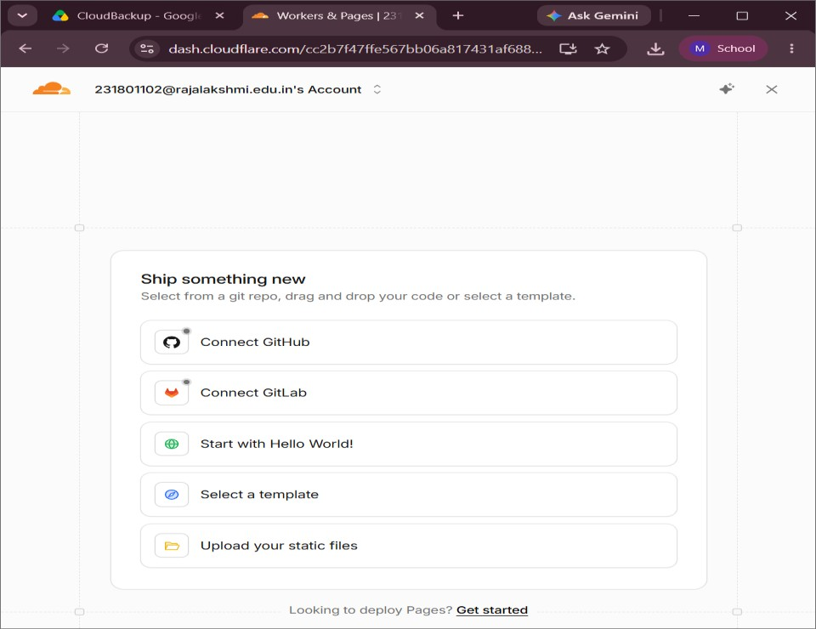
Step 3: Create a New Application
The Workers & Pages service was opened from the Cloudflare dashboard. The Create App option was selected, followed by Start with Hello World!, which created a simple Cloudflare Worker application.
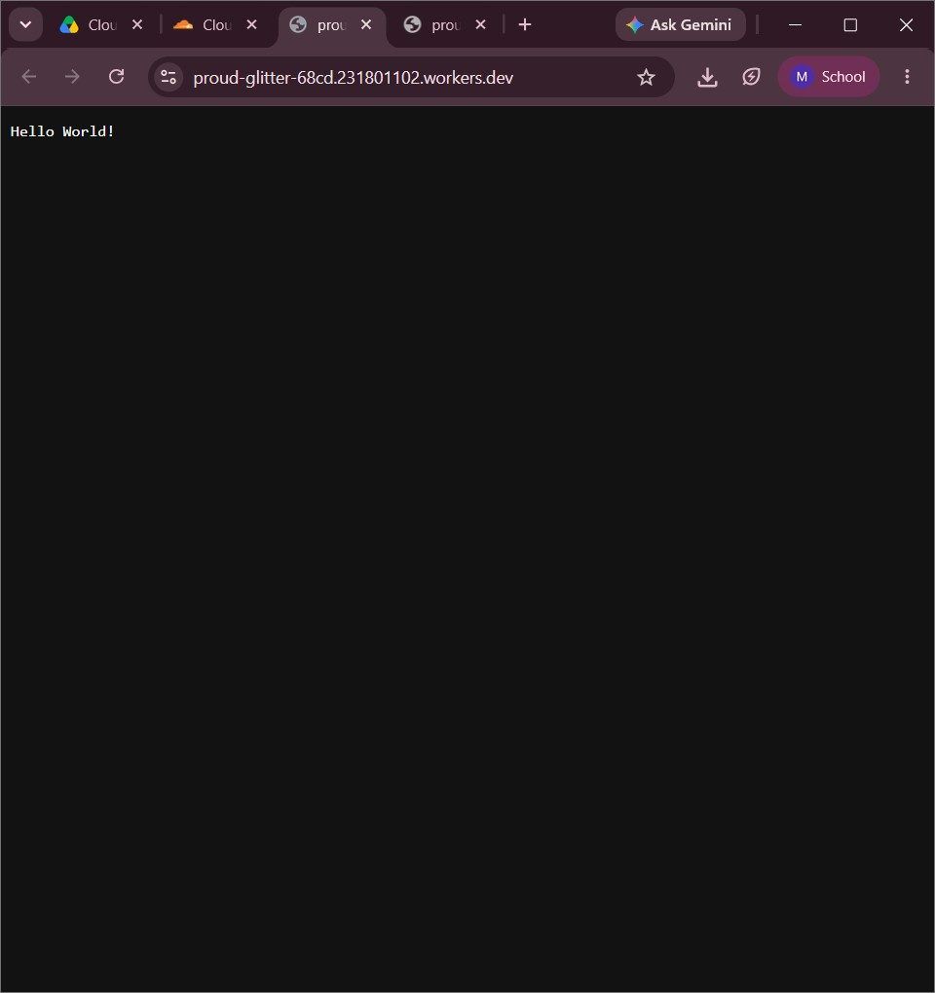
Step 4: Deploy the Hello World Application
The default Worker code was retained and deployed. The application returned the response “Hello World!”, and Cloudflare generated a public URL ending with workers.dev. The deployed application was accessed successfully through the generated public URL.

Part C – Create the CDN Demonstration Webpage
Step 5: Edit the Worker Code
The Cloudflare Worker code editor was opened, and the default Hello World response was replaced with a simple HTML webpage containing information about CDN content delivery, including:
- CDN Service Experiment
- Cloudflare Content Delivery
- This webpage is being delivered through Cloudflare
- CDN reduces the distance between users and content
- Status: Successfully Deployed
Step 6: Deploy the Updated Application
After modifying the Worker code, the application was deployed again. The updated webpage was accessed using the public workers.dev URL, and the CDN demonstration webpage was successfully displayed in the browser.
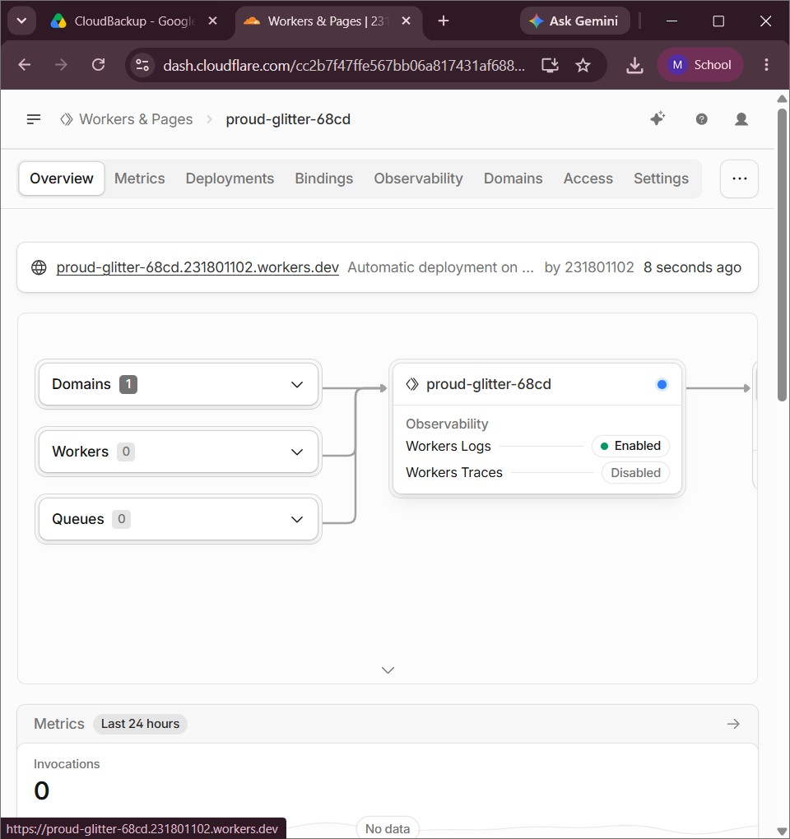
Part D – Verify the HTTP Response
Step 7: Open Browser Developer Tools
The deployed Cloudflare Worker webpage was kept open in Google Chrome, and Chrome Developer Tools were opened by pressing F12. The Network tab was selected.
Step 8: Reload the Webpage
The webpage was reloaded while the Network tab was active, and the main request generated for the Cloudflare Worker was displayed in the Network activity list.
Step 9: Inspect the Request Headers
The main Worker request was selected and the Headers section was opened. The following information was verified:
- Request Method: GET
- Status Code: 200 OK
- Content-Type: text/html
- Server: cloudflare
- CF-Ray: Cloudflare request identifier
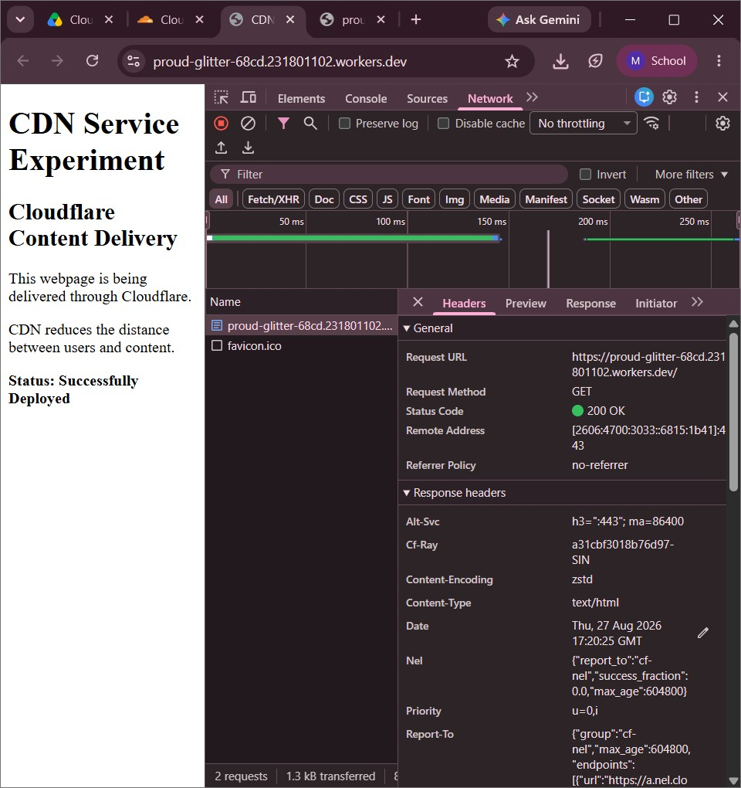

The Server: cloudflare header confirmed that the response was handled through Cloudflare's network. The CF-Ray header provided a unique identifier for tracing the request through Cloudflare's infrastructure.
CDN Content Delivery Workflow
User → Web Browser → Cloudflare Edge Network → Cloudflare Worker → HTML Response Generated → Content Delivered to User → HTTP Response Verified

Conclusion
The CDN service selection and configuration experiment was successfully carried out using Cloudflare. A Cloudflare Worker was created and deployed on Cloudflare's distributed edge network. The deployed application was accessed through a public workers.dev URL and successfully delivered the CDN demonstration webpage. Browser Developer Tools were used to inspect the network request; the response returned an HTTP status of 200 OK and included Cloudflare-specific headers such as Server: cloudflare and CF-Ray, confirming that the application request was processed and delivered through Cloudflare's edge network.

